The laboratory work 15
Part 1

Before you can do this exercise, you'll need to download and unzip this file (if you have any problems doing this, click here for help).
Movies come in a variety of different genres - these are currently stored in separate workbooks. Using the Folder data source option combine all the genres into a single data model table:
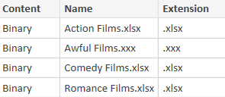
The files in the above folder that you want to combine (but see hint below).
Note that one of the files above has an .xxx extension (and so won't import properly), so after choosing to combine your files be sure to tick the Skip files with errors box.
This will give you 321 films, in 3 different genres. Return to Power BI proper and create a Table visual to compare their lengths:
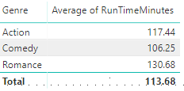
Your table should show the average run time for each genre.

It would appear that the shorter the movie, the better it is. Let's test this hypothesis by adding some truly terrible movies into our data model! Firstly, rename the file Awful Films.xxx in the above folder to Awful Films.xlsx, then load it into your data model:
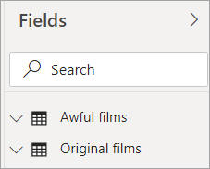
You now have two tables (which we've renamed), which you should combine as explained below.

Use the Append option in query editor to append one of these queries onto the other. You should now have 326 films in your combined table, not 321:
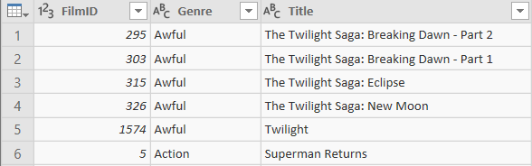
The combined table of films, beginning with the 5 awful ones (at least according to Wise Owl).
Create a column chart based upon the combined table to test your hypothesis:
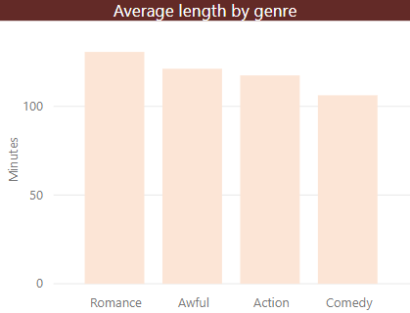
It seems as if the hypothesis doesn't stand up in the face of data!
Optionally save this as Are shorter movies better, then close it down.
Part 2
Before you can do this exercise, you'll need to download and unzip this file (if you have any problems doing this, click here for help).
One of your colleagues has created an excellent pivot table within Excel. While it may look excellent there, however, it causes problems within the data model:
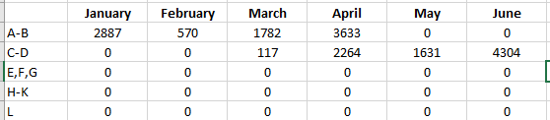
The first half of the year certainly seems to be having a promising start. Wonder if the second half is as good?
Bring this data into Query Editor and unpivot it so that it can be presented within report view. Create a line chart based on these results:
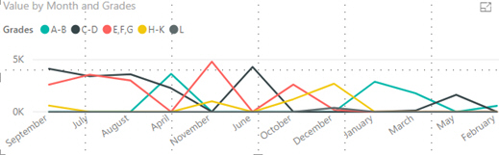
Yikes! We can't tell anything from this due to the weird month order.
Import the month numbers table from the Excel file in the above folder. Join this to your pivot table via the month names (using the month number to sort the month names):
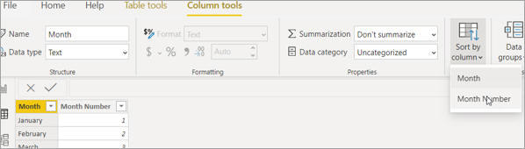
A handy feature which makes our months appear in a more logical order.
Recreate the line chart using the sorted month column from the other table, admire your sorted months:
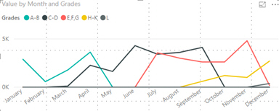
Ouch. Guess the summer holidays didn't help with focussing the mind!
Optionally save this as More grades, more green and then close it down.
Part 3
Before you can do this exercise, you'll need to download and unzip this file (if you have any problems doing this, click here for help).
Some IT savvy palaeontologist has separated the fun facts about dinosaurs from their names and pronunciations, leaving us to guess which dinosaurs these are:
We don't know what to call it - but this dino probably calls you dinner!
Using the CSV and Excel files in the above folder, merge the data together into a new table in your data model. This should look like this:
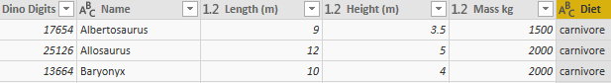
The other columns are still there just off the page (probably too scared to be near these beasts).
Since we have created a new table we don't want to import the duplicated data from our original files. Stop them from loading into the data model:
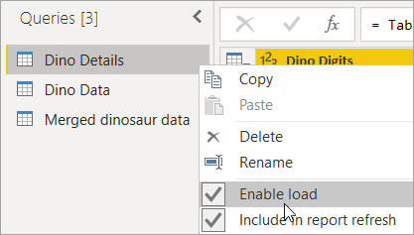
This lets us reference the original files without making our pbix file any larger with repeated data.
Optionally save this as Digging for dinos, then close it down.
Part 4
Before you can do this exercise, you'll need to download and unzip this file (if you have any problems doing this, click here for help).
Open the pbix file called Outdated Movies from the above folder, and have a look at the table visual it contains (already created in report view):
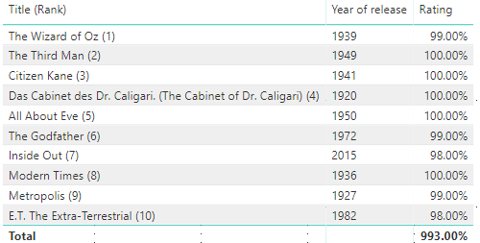
The top 10 movies according to Rotten Tomatoes as of 2016.
What we want to do is update this list to show the current top 10 films on the website. The easiest way to do this is to point the M language instructions at a different data source. First connect to the Rotten Tomatoes website:
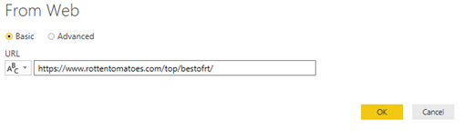
Since this is a website you may find the answer needs a refresh! As of writing the table we want is Table 2.
Once you have the data, go to the original top 100 table and from the Home tab choose Advanced editor, sadly the old connection won't work but we still get the code:
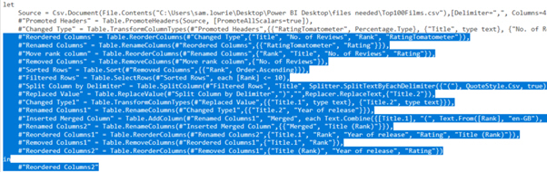
Copy all the steps from 'Reordered columns' down. We don't want a CSV file - instead we want our web connection!
Open up the Advanced editor for your web connection to the Rotten Tomatoes website:
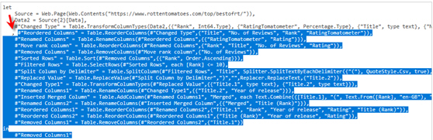
Paste your M steps in under the already generated code. Remember to add a comma in front of the first line!
Refresh your connection and admire your newly updated list. Sadly there is no short-cut for changing the report visual - you will need to recreate this:
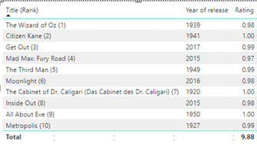
It is also worth ordering the Title (Rank) column using the Rank column.
Optionally save this as Out with the old, in with the new and then close it down.

